Actuele lesbrief Engels – Soldiers, Earthquakes, Ants
Voor de docent
Rusland kondigt een gedeeltelijke mobilisatie af, Mexico en Taiwan zijn opgeschrikt door grote aardbevingen en er zijn naar schatting meer dan 20,000,000,000,000,000 mieren op aarde.
ERK-niveau
Lezen B1 – Lezen om informatie op te doen: Kan belangrijke feitelijke informatie begrijpen in korte verslagen en artikelen. (LEB1-3a)
Leesstrategieën - Kan de betekenis van zo nu en dan voorkomende onbekende woorden afleiden uit de context en de betekenis van zinnen herleiden, op voorwaarde dat het besproken onderwerp bekend is.

Intro
Russia in war with Ukraine, earthquakes shocking other parts of the planet, and what’s up with the ants?

Assignment 1
a Find the following countries on the world map: Finland, Mexico, Russia, Taiwan, Ukraine.
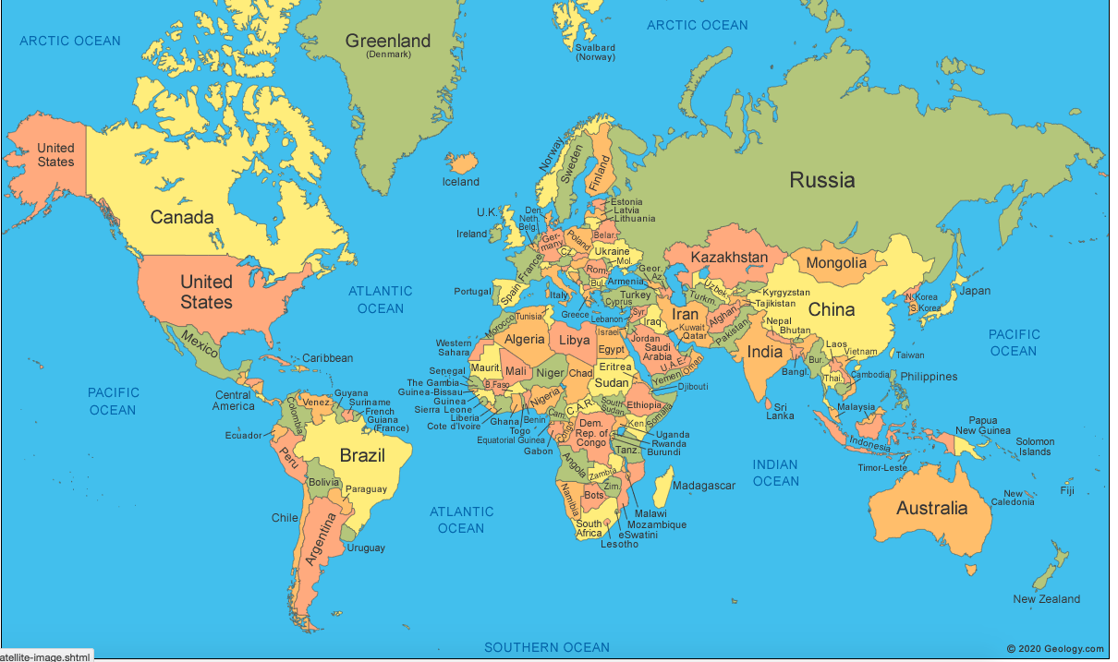

Soldiers, Earthquakes, Ants

All over the world, a lot is going on. A new roundup gives all the important information of events near and far, events in Russia and Ukraine, in Mexico and Taiwan. And also very down to earth.

Assignment 2
Read the text. Connect the words and expressions that have the same meaning in the text.
- to call up | - all the cars formed a line that moved slowly or not at all
- reserve soldiers | - to become very expensive
- to rejoin | - to find by adding (optellen), subtracting (aftrekken), multiplying (vermenigvuldigen) or dividing (delen)
- army | - a guess that you make based on the information you have
- to go sky high | - hurts, damages, wounds
- traffic was backed up | - to join again
- border | - a large group of people who are armed and trained to fight
- magnitude | - a line separating one country or state from another
- severe | - an object or tool that is used for catching animals
- aftershock | - one thousand trillion (1,000,000,000,000,000)
- injuries | - to order soldiers to come for active military duty
- quadrillion | - people with military experience who must serve in the army when they are needed
- an estimate | - size or strength
- a trap | - a smaller earthquake that follows a large earthquake
- to calculate | - very bad or serious

Assignment 3
a Connect the items on the left with the correct description on the right.
- aftershock | - Young Men Race to Leave Russia As It Calls Up Soldiers
- airplane tickets suddenly very expensive
- counting insects | - Earthquakes Strike in Mexico And Taiwan
- international scientific information
- reserve soldiers called up | - Scientists Report That Earth Has 20 Quadrillion Ants
- train knocked off the rails

b Why are there long lines at Russia’s border crossings?
1 300,000 reserve soldiers want to join the European Union army.
2 Many Russian men are leaving because they do not want to join the army.
3 There are not enough people working at the border crossings.
4 Tourists from several large cities in Russia want to visit Finland.

c “The numbers of insects around the world are dropping.” What does this mean?
1 Around the world, more and more car windows are covered in dead insects.
2 Insects that go sky high will drop dead.
3 Scientists know little about the numbers of ants living underground.
4 There are less and less insects all over the world.

