Actuele lesbrief Engels – Say Hello to Ms Marvel
Voor de docent
Het Marvel Universum is het fictieve gedeelde universum waarin de meeste stripverhalen over superhelden van Marvel Comics zich afspelen. Een van die superhelden is Kamala Khan. Volgend jaar start een nieuwe tv-serie waarin zij figureert.

ERK-niveau
Lezen A2 - Lezen om informatie op te doen – Kan de hoofdlijn begrijpen van eenvoudige teksten in een tijdschrift, krant of op een website. (LEA2-3b)
Leesstrategieën - Kan zijn of haar begrip van de algemene betekenis van korte teksten over alledaagse onderwerpen van concrete aard gebruiken om de vermoedelijke betekenis van onbekende woorden af te leiden uit de context.
Kan gebruikmaken van tweetalige (online) woordenboeken om woordbegrip te controleren, indien toegestaan.

Intro
Superhero fans can look forward to several new movies and series. One series is about Kamala Khan a.k.a. Ms Marvel.

Assignment 1
Read the assignment and write down the answers in English. You may use English-language Internet sources to help you.
a Name three or more superheroes. If you know their superpowers, write those down too.
b Some words connected to film:
actor, actress, adventure, broadcast, camera, cartoon, character, cinema, director, documentary, ending, film, hero, movie, plot, series.
Mark the words you know. Look up the words you do not know

Say Hello to Ms Marvel
A new web television series about Ms Marvel is in the make. This month the actress who will play Kamala Khan a.k.a. Ms Marvel was announced.
Read the text here.

Background Information
1 Watch this short video to understand the opening of the article.
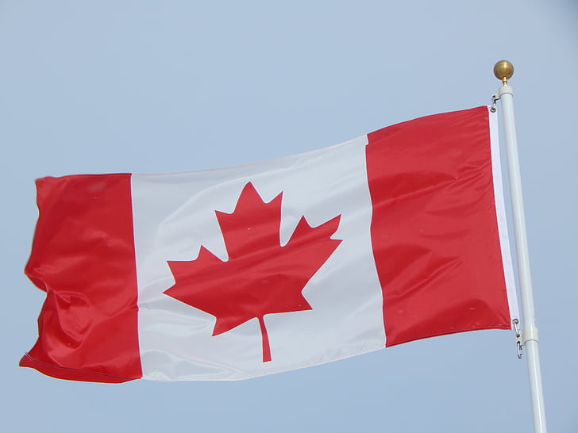
2 “— the latest casting news for a Disney Plus series has a maple twist.”
This is the flag of Canada:
It shows a picture of a maple leaf.
The “maple twist” means: the news has a connection to Canada.

Assignment 2
Read the text. Connect the words and expressions in the two columns that have the same meaning.

- a bird | - also known as (=this person also has another name)
- a plane | - an animal that has wings and is covered with feathers
- to cast | - a machine that can fly and carry people or things in the air
- the lead character | - a person who has recently started a new activity
- a newcomer | - favourite thing to eat when watching a film at the cinema
- go-to theatre snack | - legs and arms
- to congratulate | - short for: congratulations (gefeliciteerd)
- congrats | - the main role in a film or play
- to relate | - to change your shape or form into another, often by using magic
- a.k.a | - to choose for a part in a film or play
- to shape-shift | - to tell someone that you are happy because of his or her success or good luck
- limbs | - to understand and like or have sympathy for someone or something

Assignment 3
a Which statements about Iman Vellani are true?
1 She is a newcomer to the acting world.
2 She is from Markham, Ontario.
3 She is from Toronto.
4 She is a teen.
5 She is a filmmaker.
6 She is curious.
7 She is the first Canadian who plays a superhero.

b Which statements about Ms Marvel are true?
1 She is also known as Kamala Khan.
2 She comes from Canada.
3 She first appeared in a comic in 2013.
4 She can shape-shift.
5 She can stretch her arms and legs.
6 She is related to Iron Man.
7 She wants to become Vice President of the United States of America.

c Vellani talks about “stories from different genders and different countries and different people.”
What does she say about these stories?
1 Some people cannot understand these stories.
2 Stories like that are only important for people who understand them.
3 These stories are imortant to learn more about superheroes.
4 These stories can help people to understand each other better.

