Actuele lesbrief Engels – Water Wise – uitwerking
Actuele lesbrief WK 24 – B1 – Malmberg Engels 2019-2020
Opdracht | ERK niveau
Opdracht 1 | A2/B1
Opdracht 2 | B1
Opdracht 3 | B1

Assignment 1 (voorbeelduitwerking)
a boil, brook, canal, channel, clouds, condensation, dew, downpour, drain, drink, drop, flood, flow, frost, H2O, hail, humid, humidity, ice, lake, moisture, ocean, pond, pool, puddle, rain, river, sea, shower, snow, soak, steam, stream, surf, tide, water drop, waterfall, waterfront, waterproof, waterway, waves, wet, wetlands, ...
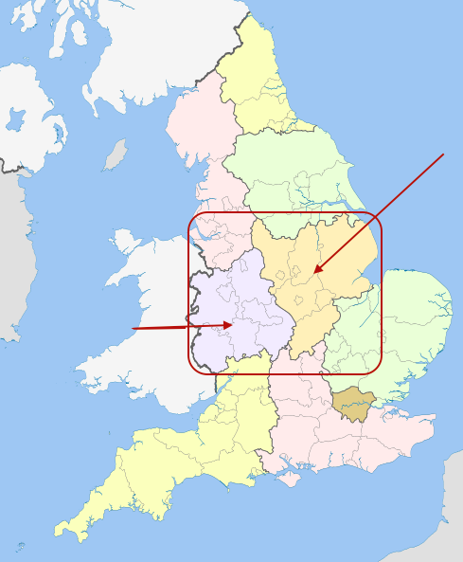
b

Assignment 2
- demand | n. the total amount of something which people want to buy and use
- surge | h. a sudden, large increase
- supplier | g. a person or company that supplies goods or services
- reservoirs | k. special lakes that are used to store a large supply of water for use in cities or other areas
- sprinklers | f. a little object with many small holes that is used to spray water on plants or soil
- water pressure | b. a force that makes a flow of water strong or weak
- rainfall | a. drops of water from clouds
- spokesman | j. someone who speaks for or represents a company
- to ramp up | d. to increase
- to ditch | i. to stop using something
- hygiene | m. the things that you do to keep yourself and your surroundings clean
- to struggle | c. to have difficulties doing or using something
- tap | e. kraan
- to run out of something | o. to use up all there is of something
- bottled water | l. water in bottles

Assignment 3
a 2 lockdown
4 surge in demand
5 warm weather

b 3 About 2000

c 2 Many people are buying it because no water is coming from the tap.

