Australian Wildlife – antwoorden

- voorbeeld:
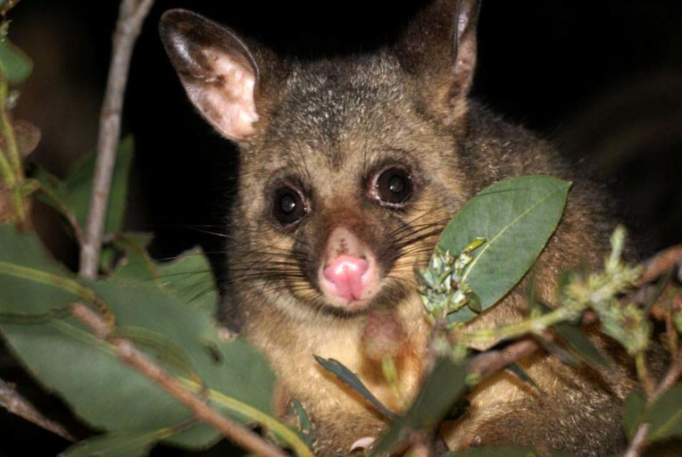
https://j6tf91d0ueo2tdwbl2hqjjle-wpengine.netdna-ssl.com/wp-content/uploads/2019/01/common_brushtail_possum2-764x512.jpg
- What little surprise did the rescuers find in the possum’s pouch?
A baby possum.
- Why are more kangaroos turning up in and near the homes of people?
They are looking for food and water, because it has been so dry for months.
- How many acres of Australian land have the fires burned down since September?
More than 10 million acres.
- Normally wildlife groups discourage people from feeding wild animals. What are they advising now?
To help the wild animals with food and water.

