Actuele lesbrief Engels – Mount Meager

Voor de docent
Vulkanen zijn de laatste tijd steeds vaker in het nieuws. Veranderingen in het klimaat worden aangewezen als een van de mogelijke oorzaken voor de toegenomen activiteit.

ERK-niveau
Lezen A2 - Lezen om informatie op te doen – Kan de hoofdlijn begrijpen van eenvoudige teksten in een tijdschrift, krant of op een website. (LEA2-3b)
Leesstrategieën - Kan zijn of haar begrip van de algemene betekenis van korte teksten over alledaagse onderwerpen van concrete aard gebruiken om de vermoedelijke betekenis van onbekende woorden af te leiden uit de context.
Kan gebruikmaken van tweetalige (online) woordenboeken om woordbegrip te controleren, indien toegestaan.

Intro
Volcanoes are in the news and not in a good way. Are they becoming more dangerous everywhere?
Assignment 1
Read the assignment and write down the answers in English. You may use English-language Internet sources to help you.
a 1 Mount Vesuvius, 2 Krakatoa, 3 Mount St. Helens, 4 Eyjafjallajökull, 5 Mount Pinatubo, 6 Mount Etna, 7 Mount Tambora, 8 Mauna Loa, 9 Mount Pelée, 10 Cotopaxi
These are ten famous volcanoes. For each one, write down in which country they are located. Then mark them all on a world map.
b Work with one or more classmates. Write down any words you know related to volcanoes.

Mount Meager
On 22 December 2018, an eruption from Anak Krakatoa triggered a deadly tsunami in Indonesia. Anak Krakatoa had been more active for several months already. Then on Christmas Eve, Mount Etna in Italy came to life. Ash rained across the Italian island of Sicily. Mount Etna is Europe’s most active volcano. There seems to be more volcano activity all over the world.
Mount Meager is a potentially active volcano in British Columbia. British Columbia is a province of Canada. Now, Canadians are asking: When will this Canadian volcano erupt? Sooner rather than later, scientists say. This has to do with climate change.  It’s just a matter of time before the Mount Meager volcano explodes, says Glyn Williams-Jones. He works as a volcanologist at Simon Fraser University. Mount Meager is “like a great, sleeping giant”. And the giant is going to wake up soon, he says. | 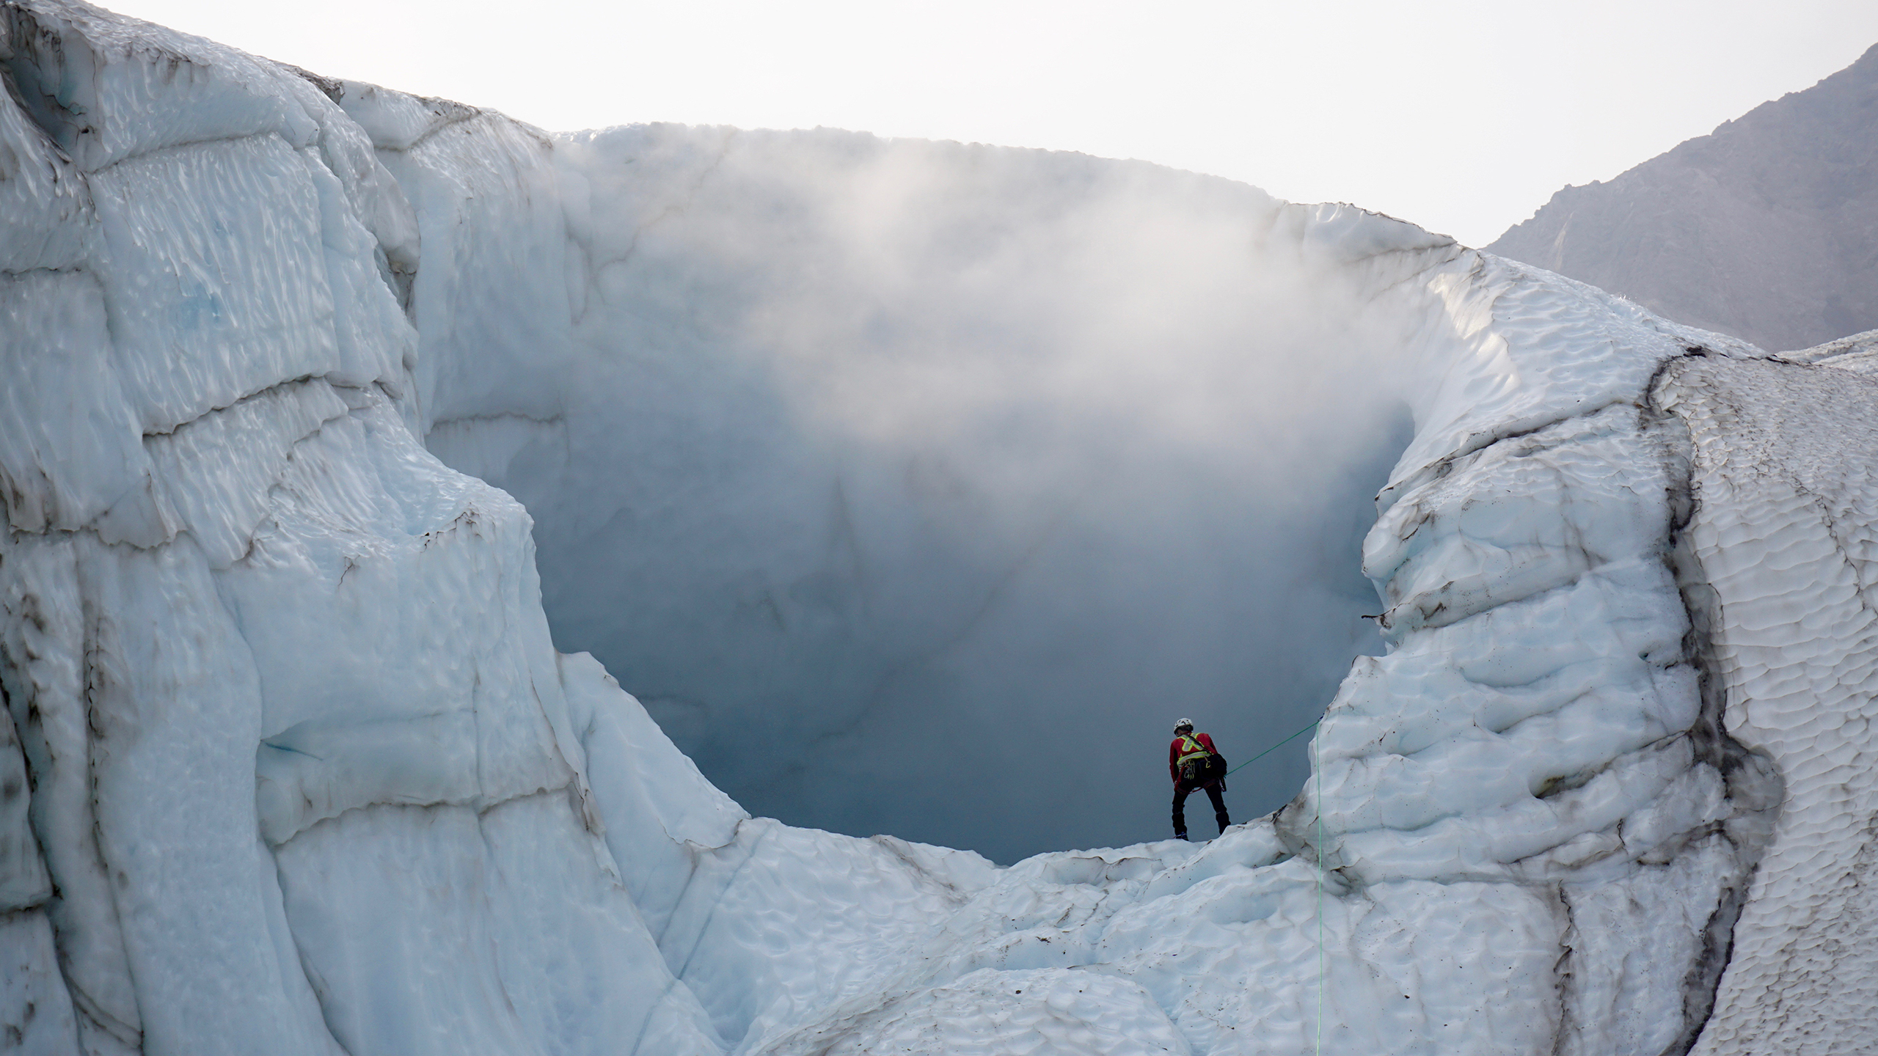  The crater of Mount Meager in British Columbia
Mount Meager is held together by a mix of rock and ice, Williams-Jones says. The volcano is becoming less stable. This is because climate change causes the ice to melt. Volcanoes each have their personalities, he adds. Mount Meager is “quiet but grumpy”.
Williams-Jones says there should be a better warning system in place. It can sound the alarm for people who live in the area when an eruption or landslide happens.
Mount Meager was the last volcano to erupt in Canada. The last time the Mount Meager volcano erupted was about 2,400 years ago. But Williams-Jones says there are signs another eruption could be coming.
Two years ago a helicopter pilot noticed three holes in the ice on top of the mountain. They were belching smoke. Williams-Jones and his team confirmed they are fumaroles. Fumaroles are openings in the mountain and ice. A mix of toxic gas and steam from deep inside the volcano escape from these openings.  “This big, massive mountain is rotten,” Williams-Jones says. | 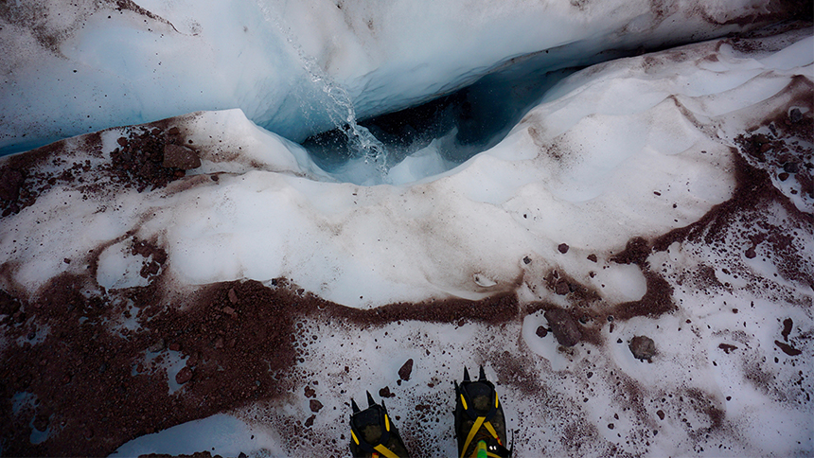  Fumarole in Mount Meager
Mount Meager is one of a string of volcanoes that run along the west coast of North America. Eruptions are unusual, but they do happen. In 1980, almost 60 people died when Mount St. Helens erupted in the U.S. There are about 5,300 people living less than 60 kilometres from Mount Meager.
Williams-Jones is calling for a round-the-clock monitoring system. The system would warn people if an eruption or landslide happened. The federal government confirmed it has no plans to pay for that kind of system right now. In the meantime, Williams-Jones is encouraging private businesses to help watch the mountain’s activity.
Based on: www.cbc.ca
Assignment 2
Read the text. Connect the words and expressions that have the same meaning in the text.
- to come to life | - a group of instruments that regularly check if everything is okay
- potentially | - a large mass of rocks and earth that suddenly moves down a mountain
- giant | - all day and all night
- in place | - containing substances that can injure or kill living things
- landslide | - having the ability or power of becoming real
- to belch | - ready to be used
- toxic | - something that is very large, powerful
- round the clock | - to become active
- monitoring system | - to push or throw something out with force

Assignment 3
a Which statements are true? For each true statement, underline or copy any sentences in the text that confirm your choice.
1 After Anak Krakatoa and Mount Etna, Mount Meager will be the next volcano to erupt.
2 Climate change is connected to a possible eruption of Mount Meager.
3 Because of all the smoke, helicopter pilots don’t fly over Mount Meager any more.
4 Currently, there is no system that would warn people when Mount Meager becomes active.
b Williams-Jones says that Mount Meager will erupt “sooner rather than later”. This means:
1 Mount Meager will only erupt during the night.
2 Mount Meager will probably erupt soon.
3 Mount Meager will probably not erupt at all.
4 Mount Meager will start erupting late at night.
c Why is Mount Meager “quiet but grumpy”?
1 The volcano does not make any noise, which is why it is extra dangerous.
2 The volcano is actually really friendly; it just looks like an unfriendly giant.
3 The volcano is not active now, but you can notice that it is angry inside.
4 The volcano is not very well known in the world; it is never in the news.

